NAME OF THE ARTICLE
Name Surname¹, Name Surname ²
¹ First author´s working compartment
² Second author´s working compartment
Abstract

Abstract contains less than 200 words. Abstract should contain: focus of the research, used research methods, research results and overall conclusion and recommendations. Abstract contains less than 200 words. Abstract should contain: focus of the research, used research methods, research results and overall conclusion and recommendations. Abstract contains less than 200 words. Abstract contains less than 200 words. Abstract should contain: focus of the research, used research methods, research results and overall conclusion and recommendations. Abstract contains less than 200 words.
Abstract should contain: focus of the research, used research methods, research results and overall conclusion and recommendations. Abstract contains less than 200 words. Abstract should contain: focus of the research, used research methods, research results and overall conclusion and recommendations. Abstract contains less than 200 words. Abstract should contain: focus of the research, used research methods, research results and overall conclusion and recommendations.
Keywords: keyword, keyword, keyword, keyword (3-6 keywords)

Introduction
Financial planning is deciding on a way of funding (obtaining capital sources) and investing funds into company property (Gazda and Ivanic, 2009). The compilation of such a plan has a crucial influence on competition strategy (Vrchota, 2013, p. 85). According to Stehel and Vochozka (2016) it is the key to business success. The output of the plan are financial statements – the planning balance sheet, profit and loss sheet and cash flow plan sheet. They are compiled for the whole planned period and are elaborated in individual accounting periods and expanded even further in individual months (Vochozka et al., 2016).
Financial planning is deciding on a way of funding (obtaining capital sources) and investing funds into company property (Gazda and Ivanic, 2009). The compilation of such a plan has a crucial influence on competition strategy (Vrchota, 2013, p. 85). According to Stehel and Vochozka (2016) it is the key to business success. The output of the plan are financial statements – the planning balance sheet, profit and loss sheet and cash flow plan sheet. They are compiled for the whole planned period and are elaborated in individual accounting periods and expanded even further in individual months (Vochozka et al., 2016). Financial planning is deciding on a way of funding (obtaining capital sources) and investing funds into company property (Gazda and Ivanic, 2009). The compilation of such a plan has a crucial influence on competition strategy (Vrchota, 2013, p. 85).

Headline of second level
According to Stehel and Vochozka (2016) it is the key to business success. The output of the plan are financial statements – the planning balance sheet, profit and loss sheet and cash flow plan sheet. They are compiled for the whole planned period and are elaborated in individual accounting periods and expanded even further in individual months (Vochozka et al., 2016).
Methodics
We will therefore search for the dependence of sales of a commercial enterprise on production factors, or the expenditure of which. Profit and loss statements for the years 1999-2015 are available, a total of 17 entries for each item of a profit and loss account.
For the purpose of fulfilling the objectives of the article, we will be interested in these profit and loss entries:
- sales of goods,
- the cost of goods sold,
- personnel expenses
- depreciation of tangible and intangible fixed assets.
Results
We have obtained the five best neuron networks by generation as described in the methodics of the study. They are listed in the table numbered 1.

Table 1: Name of the table
Index | Profile | Train Perf. | Select Perf. | Test Perf. | Train Error | Select Error | Test Error | Training/ Members
1 | RBF 2:2-4-1:1 | 0,036897 | 0,155233 | 0,235495 | 0 | 0 | 0 | KM,KN,PI
2 | RBF 3:3-3-1:1 | 0,096987 | 0,049225 | 0,272203 | 0 | 0 | 0 | KM,KN,PI
3 | RBF 3:3-5-1:1 | 0,046234 | 0,119551 | 0,222529 | 0 | 0 | 0 | KM,KN,PI
4 | RBF 3:3-4-1:1 | 0,091352 | 0,079881 | 0,261555 | 0 | 0 | 0 | KM,KN,PI
5 | RBF 1:1-4-1:1 | 0,030387 | 0,019384 | 0,035051 | 0 | 0 | 0 | KM,KN,PI
Source: name of the source
The neural structures are composed of three layers: the input layer, hidden layer and output layer of neurons. The first neural network works with two entrances. The second, third and fourth work with all factors of production. The fifth, on the contrary, assumes the use of a single factor of production for prediction.
- sales of goods,
- the cost of goods sold,
- personnel expenses.
Indicator find the following formula:
 | $$\text{ROE=}\frac{\text{Earning After Tax (EAT)}}{\text{Total Equity}}\text{*100}$$ | (1)
The neural structures are composed of three layers: the input layer, hidden layer and output layer of neurons. The first neural network works with two entrances. The second, third and fourth work with all factors of production. The fifth, on the contrary, assumes the use of a single factor of production for prediction.
Discussion
The neural structures are composed of three layers: the input layer, hidden layer and output layer of neurons. The first neural network works with two entrances. The second, third and fourth work with all factors of production. The fifth, on the contrary, assumes the use of a single factor of production for prediction. The first neural network works with two entrances. The first neural network works with two entrances. The first neural network works with two entrances. The first neural network works with two entrances. The first neural network works with two entrances. The first neural network works with two entrances. The first neural network works with two entrances. The first neural network works with two entrances. The first neural network works with two entrances. The first neural network works with two entrances.
Figure 2: Name of the figure
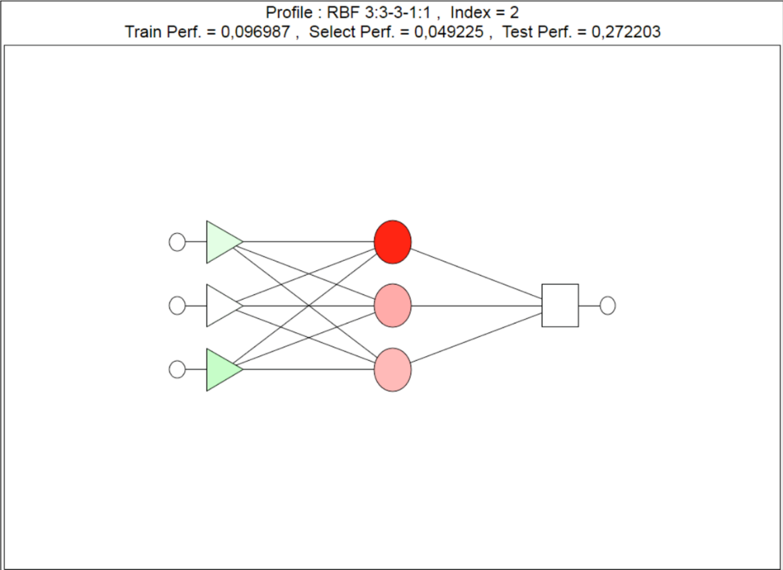
Source: name of the source
Conclusion
The aim of this paper was to find a suitable RBF neural network for predicting sales on the example of a particular company.
The aim of the paper has been met. Top five neural structures have been generated and retained. There have been no fundamental differences identified among the predicted values of individual networks. All generated networks are usable for the evaluated the company. The sensitivity analysis subsequently found that it is possible to estimate future revenues based primarily on the cost of goods sold and personnel costs. The depreciation of fixed assets was seen as an irrelevant variable to calculate revenue.
Acknowledgement
The aim of this paper was to find a suitable RBF neural network for predicting sales on the example of a particular company.
References
HARVARD REFERENCING STYLE – EXAMPLES

Monograph - printed
SURNAME, INITIALS., Year of publication. Title. Place of publication: Publisher. ISBN 00-00000-00-0.

1 author:
WANG, A., 2015. Title. Place of publication: Publisher. ISBN 00-00000-00-0.

2-3 authors:
PAULSEN, P., I. JOHANSON and E. NESTOR, 2004. Neural structures and other artificial intelligence. Stockholm: Swedish Institution Press. ISBN 00-00000-00-0.

4 and more authors:
SONDER, P. et al., 1967. Most important financial statements. Cambridge, MA: Harvard University Press. ISBN 00-00000-00-0.

Monograph – electronic – issued online
SURNAME, INITIALS., 2005. Title [online]. Place of publication: Publisher, 2014-10-19 [accessed: 2016-10-25]. ISBN 00-00000-00-0. Available at: URL.

Chapter in monograph, contribution in proceeding – printed

SURNAME, INITIALS., Year of publication. Title of Chapter. In: SURNAME, INITIALS., Title of monograph or proceeding. Place of publication: Publisher, Page numbers from–to. ISBN 00-00000-00-0.

Chapter in monograph, contribution in proceeding – electronic – issued online

SURNAME, INITIALS., Year of publication. Title of Chapter. In: SURNAME, INITIALS., Title of monograph or proceeding [online]. Place of publication: Publisher, Date of Publishing year-month-day, Page numbers from–to [accessed: year-month-day]. ISBN 00-00000-00-0. Available at: URL.

Journal article - printed

SURNAME, INITIALS., Year of publication. Title of article. Title of journal. volume(number), page numbers from-to. ISSN 0000-0000.

Journal article - electronic

SURNAME, INITIALS., Year of publication. Article title. Journal title [online]. Place of publication: Publisher, volume(number), page numbers from-to [accessed: year-month-day]. ISSN 0000-0000. Available at: URL.

Website entirely (Date of issue = Date of last update)

NAME OF THE OWNER/AUTHOR., Date of last update/copyright. Name of the webpage. [online]. Place: Publisher, Date of Publishing. [accessed: year-month-day]. Available at: URL.
Website – selected text (is not article in journal, proceeding or monograph)

NAME OF THE OWNER/AUTHOR., Date of last update/copyright. Name of the text. In: Name of the webpage. [online]. Place: Publisher, Date of Publishing. [accessed: year-month-day]. Available at: URL.

Law - printed
NAME OF THE COUNTRY, Year of publication. Law title. In: Collection of laws title. Edition number, page numbers from-to. ISSN 0000-0000.

Law – online at portal.gov.cz

NAME OF THE COUNTRY. Law title. In: Portál veřejné správy České republiky [online]. Ministry of Commerce [accessed: year-month-day].

Regulation (of certain Institution) – printed
NAME OF THE COUNTRY. Name of the Institution. Regulation number, date and title. In: collection of laws title, Czech Republic. Edition number, page numbers from-to. ISSN.

Contact address of the author(s):
doc. Name Surname, Ph.D., Department, Faculty, Name of employer, Full address, Country/State, e-mail: email@email.cz

